**1**

**Chapter 1**

**Introduction**

* 1. **Overview of the system:**

Flow measurement is the quantification of bulk fluid movement. Flow meter the name suggest, devices that measure flow in a piped system. Depending on the application, flowrate is measured as either volume or mass.

In this project we are focusing on design of digital flow meter system which will give a digital output. This flow meter constructed using low cost system. This Flow meter is used to provide accurate monitoring and/or flow control. Industrial applications require precise calculations of quantity, that’s why our main objective is to come up with cost effective digital flow meter.

Hall Effect sensor is used as a sensing unit with turbine rotor inside it whose speed of rotation changes with the rate of flow of water. The meter is attached between the pipes, where we want to measure the flow of water. The Hall Effect sensor outputs the corresponding pulse train for frequency input to microcontroller.

The whole system comprises of Atmega328P microcontroller, Hall Effect Sensor, a water pump, 5V power supply, OLED display, some passive components.

* 1. **Problem statement:**

Industrial applications require precise calculation of quantity. Many flow meter are available like mechanical or in analog format which have less accuracy and high maintenance. So we have to come up with compact, more accurate, and digital water flow meter.

* 1. **Objectives:**

The main objective of this project to create a cost efficient digital flow meter. Also keeping in mind the **Make In India** concept we want to provide digitalizied water flow meter.This will provide accurate and precised digital flow meter.

**Chapter 2**

**Literature Survey**

**2.1 Literature Review:**

We have studied many previous works done in this field by different researchers. Lot of research work has been carried out for evolving different water flow measurement techniques.

[1] Young-Woo Lee et. al (2008) had developed a wireless Digital Water Meter with Low Power Consumption for Automatic Meter Reading in which they used magnetic hole sensors to calculate the amount of water consumption and they had used ZigBee wireless protocol to transfer amount of water consumption to the gateway.

[2] Zhang Wenzhaoet. al (2010) had developed a liquid differential pressure flow sensor for Straight Pipe. In this system a pressure difference between the upstream branch pipe and the downstream pipe is detected and converted into a voltage signal by the DP sensor. This voltage signal is transmitted to a microprocessor to determine liquid flow rate.

[3] Ria Sood1, Manjit Kaur2, Hemant Lenka3 (2013) Effective irrigation water management begins with timing and regulating irrigation water application in a

way that will satisfy the need of the crop without wasting water, soil and crop nutrients. This paper describes design and development of low cost automatic

water flow meter which supplies only required amount of water to the crops saving water as well as energy.

[4]

**2.2 Market Survey:**

**2.2.1 Mechanical Flow meter**

with each other and its shell (measuring room). or has no rotating torque even it effected the liquid pressure, but the above gears will move by the rotating Pressure .ln the status of the above gears driving gear, and the bottom gear is driven gear. both of these two gears have rotating torque by the liquid pressu/'e, and they move with the direction of the arrow to space The gear space is opposite to, The figure shows that the flow meter works by two elliptical gears to mesh with each other, its working process are as follows: P1 in the figure shows the pressure of liquid from inlet side, to show the outlet pressure, the bottom rot the bottom gear is driving gear, and above gear is driven gear. The bottom gear pushes the liquid out from the half moon space under the liquid press pushes liquid volume four times of "measurement room". So, as long as the rotation of gears, the liquid volume can be counted.The measurement part of oval gear flow meter is posed by two elliptical gears mesh

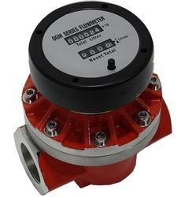

**2.2.2Electromagnetic Flow meter**

**Electromagnetic Water Flow Meter**are intended for measuring flow of electrically conductive liquids in closed pipe lines where the magnetic flux permeates the entire cross sectional area of the liquids flow. Electromagnetic flow meters measure electromotive forces to determine liquids velocity using Faraday’s law of electromagnetic induction and compute the flow rate using equation of conductive liquids having minimum conductivity of 5 micro Siemens / cm and are relatively immune to the effects of temperature , pressure , viscosity & density of the flowing liquid.

|  |
| --- |
|  |

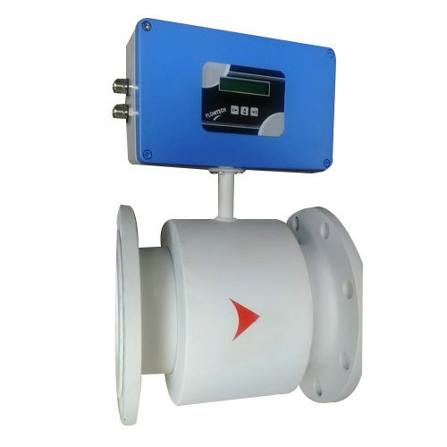

**Technical Detail:**

* Material of Construction: MS, SS 304, SS 316 & SS 316L
* Electrode Material: SS 316, SS 316L, Hastelloy ‘c’, & Tantalum
* Flow Tube Material: SS 316
* End Connection: Flange/Wafer
* Flange- Standard: ANSI B 16.5 150 #RF / 300 # RF
* Measuring Range: 0.5 m/sec for Minimum & 5m/sec for Maximum
* Accuracy: ± 1%
* FSD Optional: ±0.5% FSD
* Repeatability: 0.3%
* Display: 2 Line Alfa Numeric LCD
* Display Version: Integral /Remote
* Display Unit: Standard Unit in M3, Litre
* Power Supply: 230 VAC, 110 VAC & 24 VDC
* Output: Std. 4 – 20 mA
* Installation: Inline Flange Type.

**2.2.3 Ultrasonic Flow meter**

Bronkhorst Ultrasonic Flow meter for very small flow rates:

The new Bronkhorst® ES-FLOW is designed to measure tiny volume flows (from 4 to 1500 ml/min based on H2O) using ultrasound in a small bore tube. A wide range of clear liquids can be measured independent of fluid density, temperature and viscosity.  
 Due to the combination of a straight sensor tube with zero dead volume, self-drainability, orbital TIG-welding and hygienic connections, this flow meter can be used for hygienic applications. Wetted parts are made of stainless steel, except for the rubber gaskets at the Triclamp or flange connections. The exterior design is according to IP67. For non-hygienic applications, the instruments can also be equipped with compression type fittings.

The user interface is a capacitive touchscreen with a TFT display to operate and readout the instrument. The on-board PID controller can be used to drive a control valve or pump for precise batch or continuous dosing of samples or additives.

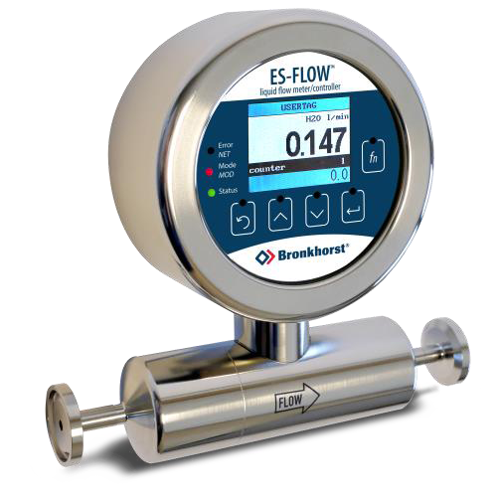

Specifications:

* Flow range : Capacity4……1500ml/min
* Accuracy : +-1% Rd+-1 ml/min
* Repeatability : <=0.1% Rd+- 0.05 ml/min
* PC – board : Integrated PID controller
* Outputs : Digital, Analog or pulse
* Response time : <= 2000msec
* Refresh(cycle) time: <=10 msec

**Chapter 3**

**System Design**

**3.1 Block Diagram**

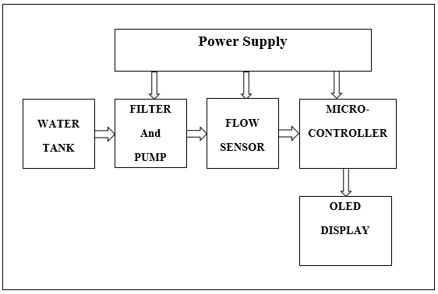

Fig. Block diagram

**3.2 Component List**

1. Microcontroller
2. LM117
3. Hall Effect Sensor
4. Magnet
5. Resistor
6. Capacitor
7. Diode
8. LED
9. Reset Button
10. OLED Display
    1. **Component selection**
       1. **Power supply**
11. **Transformer**:

A Transformer is a static apparatus, with no moving parts, which trasnforms electrical power from one circuit to another with changes in voltage and current and no change in frequency. We are using a step down transformer is a type of transformer, which converts a high voltage at the primary side to a low voltage at the secondary side.

The power in a transformer is rated in Volt-Amps VA(or Kilo Volt-Amps kVA for larger transformers). In our project we are using 230V to 12 V step down transformer, current rating of our transformer is 1 amp.

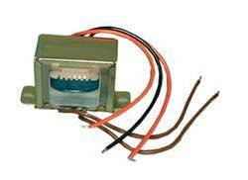

Fig. Step down transformer

1. **Bridge Rectifier:**

A Bridge Rectifier is a diode common application, which is used to converting Alternating Current (AC) input into Direct Current (DC) output. A diode bridge is an arrangement of four diodes in a bridge circuit configuration that provides the same polarity of output for either polarity of input.

Average Forward Current (Io): 1.5Amps  
Peak Reverse Voltage: 50Volt  
Peak Forward Surge Current (Ifsm): 50A  
Case: WOM  
Junction Operating Temperature (Tj): -55 to +125°C

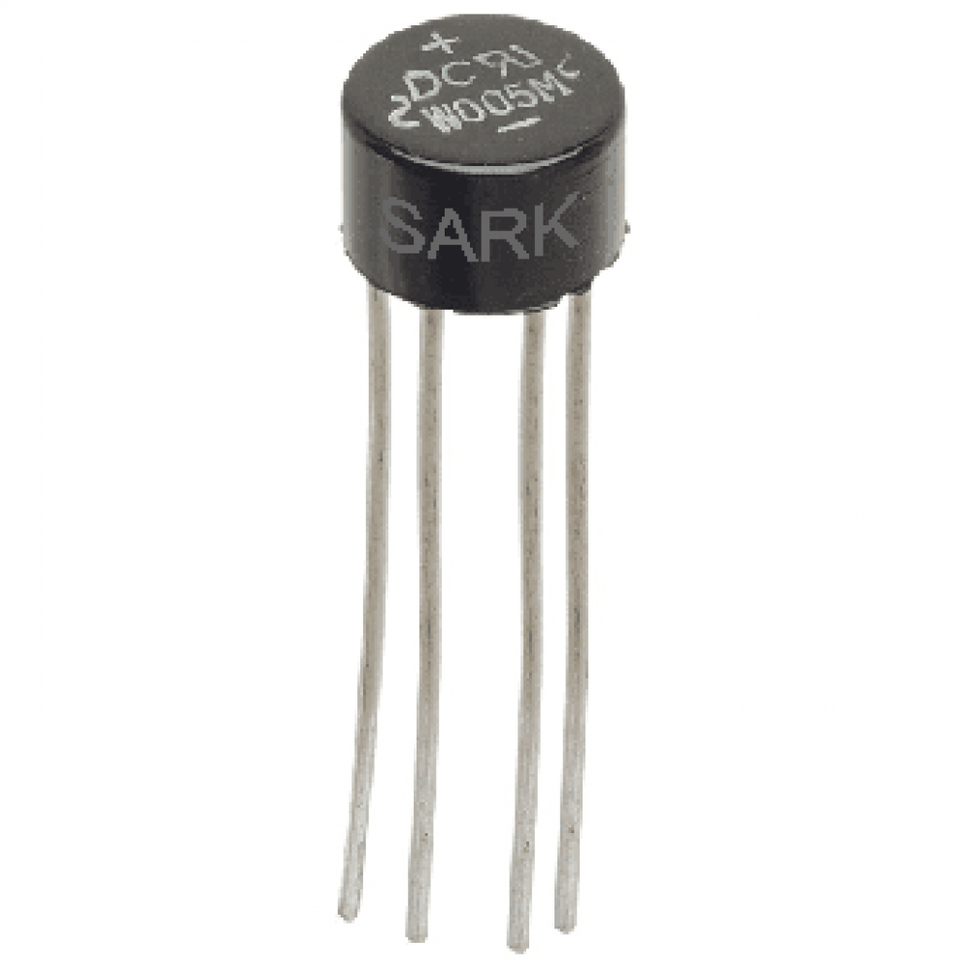

Fig. Bridge Rectifire

1. **LM117**:

The LM117 series of adjustable 3-pin positive voltage regulators are capable of supplying in excess of 1.5 A over a 1.25 V to 37 V output range and a wide temperature range. They are exceptionally easy to use and require only two external ressistors to set the output voltage. Further, both line and load regulation are better than standard fixed regulators.

The LM117 offer full overload protection such as current limit, thermal overload protection and safe area protection. Akk overload protection circuitary fully functional even if the adjustment terminal is disconnected.

Typically, no capacitors are needed unless the device is situated more than 6 inches from the input filter capacitors, in which case an input bypass is needed. An optional output capacitor can be added to improve transient response. The adhustment terminal can be bypassed to achieve with standard 3 terminal regulators.

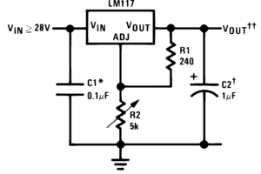 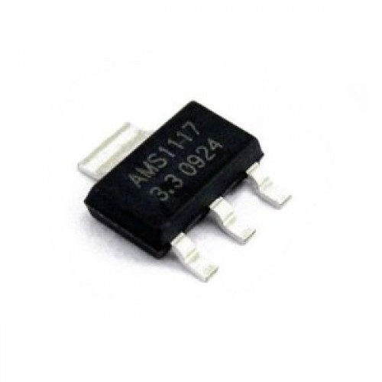

Fig. LM117 Regulator

Features:

* Typ. 0.1% Load Regulation
* Typ. [0.01 %/ V](mailto:0.01@/V) Line Regulation
* 1.5 A Output Current
* Adjustable Output Down to 1.25 V
* Current Limit constant with Temperature
* 80 dB Ripple Rejection
* Short Circuit Protected Output
* -55o C to 150o C Operating Temperature Range

1. **Resistor**:

A **resistor** is a [passive](https://en.wikipedia.org/wiki/Passivity_(engineering)) [two-terminal](https://en.wikipedia.org/wiki/Terminal_(electronics)) [electrical component](https://en.wikipedia.org/wiki/Electronic_component) that implements [electrical resistance](https://en.wikipedia.org/wiki/Electrical_resistance) as a circuit element. In electronic circuits, resistors are used to reduce current flow, adjust signal levels, to divide voltages, [bias](https://en.wikipedia.org/wiki/Biasing) active elements, and terminate [transmission lines](https://en.wikipedia.org/wiki/Transmission_line), among other uses. High-power resistors that can dissipate many [watts](https://en.wikipedia.org/wiki/Watt) of electrical power as heat, may be used as part of motor controls, in power distribution systems, or as test loads for [generators](https://en.wikipedia.org/wiki/Electric_generator). Fixed resistors have resistances that only change slightly with temperature, time or operating voltage. Variable resistors can be used to adjust circuit elements (such as a volume control or a lamp dimmer), or as sensing devices for heat, light, humidity, force, or chemical activity.

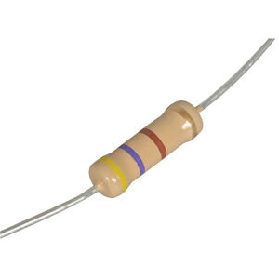

Fig. 470 Ohm 5% resistor

1. **Capacitor**:

A **capacitor** is a [passive](https://en.wikipedia.org/wiki/Passivity_(engineering)) [two-terminal](https://en.wikipedia.org/wiki/Terminal_(electronics)) [electronic component](https://en.wikipedia.org/wiki/Electronic_component) that stores [electrical energy](https://en.wikipedia.org/wiki/Electrical_energy) in an [electric field](https://en.wikipedia.org/wiki/Electric_field). The effect of a capacitor is known as [capacitance](https://en.wikipedia.org/wiki/Capacitance). While some capacitance exists between any two electrical conductors in proximity in a [circuit](https://en.wikipedia.org/wiki/Electric_circuit), a capacitor is a component designed to add capacitance to a circuit.

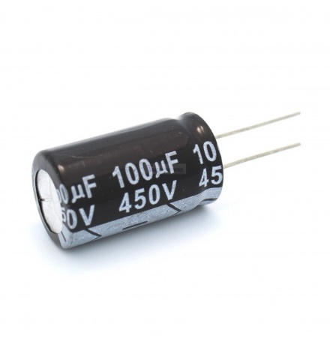 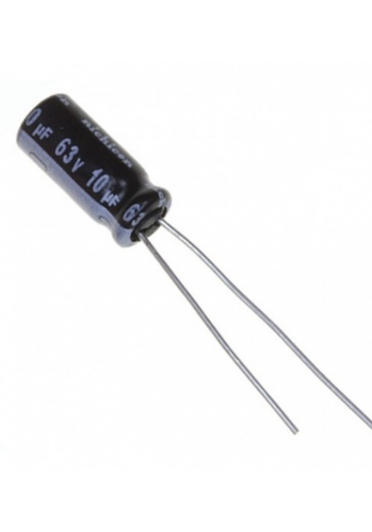

Fig. Capacitor

**3.3.2 Microcontroller: ATmega328P**

**Features:**

High Performance, Low Power Atmel®AVR® 8-Bit Microcontroller Family

• Advanced RISC Architecture

– 131 Powerful Instructions

– Most Single Clock Cycle Execution

– 32 x 8 General Purpose Working Registers

– Up to 20 MIPS Throughput at 20MHz

– On-chip 2-cycle Multiplier

• High Endurance Non-volatile Memory Segments

– 32KBytes of In-System Self-Programmable Flash program

Memory

– 1KBytes EEPROM

– 2KBytes Internal SRAM

– Write/Erase Cycles: 10,000 Flash/100,000 EEPROM

– Data Retention: 20 years at 85°C/100 years at 25°C(1)

– Optional Boot Code Section with Independent Lock Bits

• In-System Programming by On-chip Boot Program

• True Read-While-Write Operation

– Programming Lock for Software Security

• Peripheral Features

– Two 8-bit Timer/Counters with Separate Prescaler and Compare Mode

– One 16-bit Timer/Counter with Separate Prescaler, Compare Mode, and Capture Mode

– Real Time Counter with Separate Oscillator

– Six PWM Channels

– 8-channel 10-bit ADC in TQFP and QFN/MLF package

• Temperature Measurement

– 6-channel 10-bit ADC in PDIP Package

• Temperature Measurement

– Two Master/Slave SPI Serial Interface

– One Programmable Serial USART

– One Byte-oriented 2-wire Serial Interface (Philips I2C compatible)

– Programmable Watchdog Timer with Separate On-chip Oscillator

– One On-chip Analog Comparator

– Interrupt and Wake-up on Pin Change

• Special Microcontroller Features

– Power-on Reset and Programmable Brown-out Detection

– Internal Calibrated Oscillator

– External and Internal Interrupt Sources

– Six Sleep Modes: Idle, ADC Noise Reduction, Power-save, Power-down, Standby, and Extended Standby

• I/O and Packages

– 23 Programmable I/O Lines

– 28-pin PDIP, 32-lead TQFP, 28-pad QFN/MLF and 32-pad QFN/MLF

• Operating Voltage:

– 1.8 - 5.5V

• Temperature Range:

– -40°C to 105°C

• Speed Grade:

– 0 - 4MHz @ 1.8 - 5.5V

– 0 - 10MHz @ 2.7 - 5.5V

– 0 - 20MHz @ 4.5 - 5.5V

• Power Consumption at 1MHz, 1.8V, 25°C

– Active Mode: 0.2mA

– Power-down Mode: 0.1μA

– Power-save Mode: 0.75μA (Including 32kHz RTC)

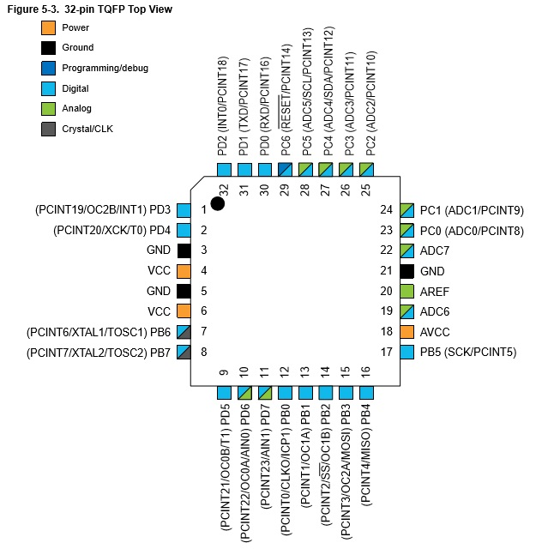

Fig. Pin diagram of ATmega328P

**3.3.3 Sensor:**

The SS360 High Sensitivity Latching Digital Hall Effect Sensor ICs are small, sensitive and versatile devices that are operated by the magnetic field from a permanent magnet or an electromagnet.

The SS360NT is turned on by a North Pole while the SS630ST are turned on by a South Pole. These sensor ICs offer reliable switching points with a high magnetic sensitivity of 30G typical (55G maximum).

They do not use chopper stabilization on the Hall element , providing a clean output signal and faster latch response time when compared to competitive high sensitivity Hall-effect latching sensor ICs which do use chopper stabilization.

These products offer reverse polarity protection, deliver a stable output over a -40oC to 150oC tempraturee range , and brushless dc motor manufacturer is who need latching sensors with reliable, consistent performance for more efficient and smaller designs

This High sensitivity Hall Effect Latching Digital Sensor ICs respond to low magnetic field and offer consistent repeatiability while delivering faster response times to a change in magnetic field for better motor efficiency.

**Features**

* Fastest response time inits class
* Not chopper –stabilization
* High sensitivity
* Latching manetics
* Wide operating voltage range of 3 Vdc to 24 Cdc
* Built –in rever se voltage
* Durable design
* RoHS- complaint material meets Direictive 2002/95

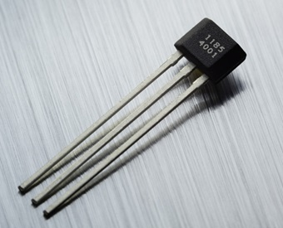

Fig. Pin diagram Hall effect sensor

**3.3.4 Magnet**

Here we, firstly used single circular magnet but that magnet unable to give proper magnetic field strength that’s why we are using two circular magnet attached to each other, which increases the field strength.

We are using this circular magnet because it will provide better field strength and it is attached to the shaft of the rotor wheel.

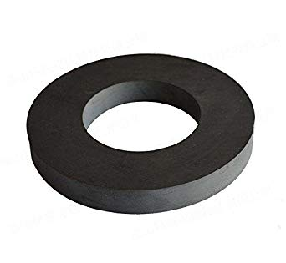

**Fig. Circular Magnet**

**3.3.5 Water Pump**

* Water Pump Of Air Cooler Frequency: 50Hz
* Used In Evaporative Air Cooler And Water Cooler Etc
* Voltage/Frequency:220V/50Hz
* Current: 0.23A
* Power : 18W Follow 1.12&Quot
* Meter High Water Flew 24L/Min Pumping Head 1.8 M
* Pump Height : 4Ft Approx [To Threw Water]

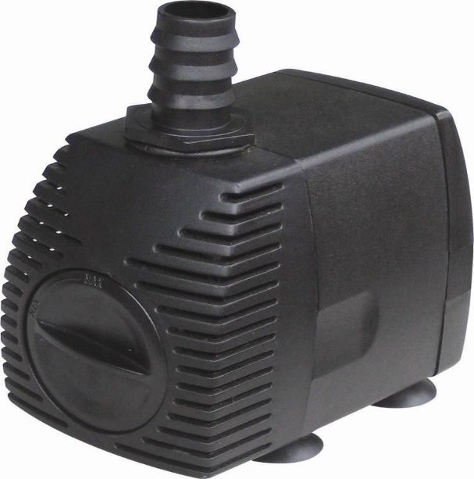

Fig. 12V water pump

**3.3.6 Resistor**

Resistor 10K SMD 1206-100Pc

This is a 10KΩ  resistor 1/4 W  rated 1% in 1206  SMD package.

Here we are using **four** **10K** **SMD** resistor for OLED display, and **1K** resistor for internal power supply unit.

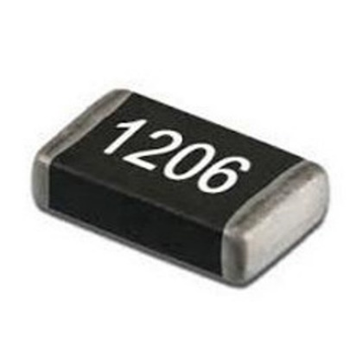 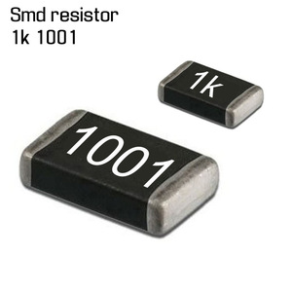

Fig. 10K and 1K SMD resistor

**3.3.7 Capacitor**

Here we are using 1uF electrolytic capacitor for internal power unit and 22uF ceramic capacitor for the circuitory.

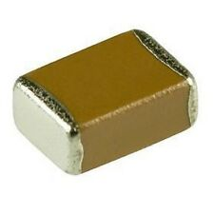

Fig. SMD capacitor

**3.3.8 LED**

A light-emitting diode (LED) is a [semiconductor](https://en.wikipedia.org/wiki/Semiconductor) [light source](https://en.wikipedia.org/wiki/Light_source) that emits light when [current](https://en.wikipedia.org/wiki/Electric_current) flows through it. [Electrons](https://en.wikipedia.org/wiki/Electron) in the semiconductor recombine with [electron holes](https://en.wikipedia.org/wiki/Electron_hole), releasing energy in the form of [photons](https://en.wikipedia.org/wiki/Photon). This effect is called [electroluminescence](https://en.wikipedia.org/wiki/Electroluminescence).[[5]](https://en.wikipedia.org/wiki/Light-emitting_diode#cite_note-5) The color of the light (corresponding to the energy of the photons) is determined by the energy required for electrons to cross the [band gap](https://en.wikipedia.org/wiki/Band_gap) of the semiconductor.[[6]](https://en.wikipedia.org/wiki/Light-emitting_diode#cite_note-6) White light is obtained by using multiple semiconductors or a layer of light-emitting phosphor on the semiconductor device.

**3.3.9 Reset Button**

A push-button (also spelled pushbutton) or simply button is a simple [switch](https://en.wikipedia.org/wiki/Electrical_switch) mechanism for controlling some aspect of a [machine](https://en.wikipedia.org/wiki/Machine) or a [process](https://en.wikipedia.org/wiki/Process_(engineering)).

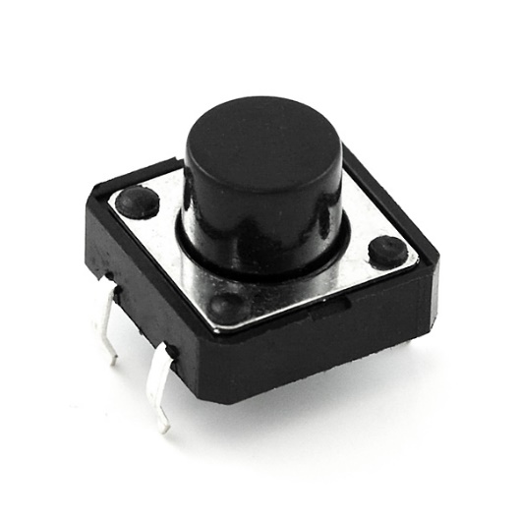

Fig. Push button

**3.3.10 Display**

**OLED**

**Features:-**

* Work perfectly well without the need of back light.
* 128*64 high resolution, ultra wide viewing angle
* Super low power consumption–only 0.08W when the whole screen lights up and 0.06W when displaying characters
* Fully compatible with multiple controlling chips including Arduino and more.
* Support a wide range of voltage input

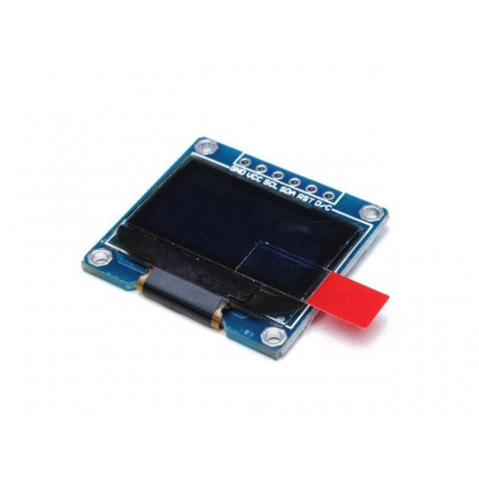

**Specifications:-**

* OLED Driver IC: SSD1306
* Resolution: 128 x 64
* Visual Angle: >160°
* Display Color: Area Color (White)
* Input Voltage: 3.3V ~ 6V
* Compatible I/O Level: 3.3V, 5V
* Mini Size: 2.7 x 2.8cm
* Only Need 2 I/O Port to Control
* Full Compatible with Arduino
* Working temperature: -30°C ~ 70°C
* Module volume ( generous ): 27.0 x 27.0 x 4.1mm
  1. **Software Used**
  2. **Diptrace**

DipTrace is an EDA/CAD software for creating [schematic](https://en.wikipedia.org/wiki/Schematic) diagrams and [printed circuit boards](https://en.wikipedia.org/wiki/Printed_circuit_board). The developers provide a multi-lingual interface and tutorials.

DipTrace has 4 modules: schematic capture editor, PCB layout editor with built-in shape-based [autorouter](https://en.wikipedia.org/wiki/Autorouter" \o "Autorouter) and 3D-preview & export, component editor, and pattern editor.

This software used to design the internal PCB design.

* 1. **Ardiuno**

Arduino programs are written in the Arduino Integrated Development Environment (IDE). Arduino IDE is a special software running on your system that allows you to write sketches (synonym for program in Arduino language) for different Arduino boards. The Arduino programming language is based on a very simple hardware programming language called processing, which is similar to the C language. After the sketch is written in the Arduino IDE, it should be uploaded on the ATmega328P microcontroller for execution.

Here we are using **CP2102** to burn the code on the microcontroller.

* 1. **Proteus**

Proteus is used to design the schematic circuit/diagram and PCB design for power supply.

The PCB Layout module is automatically given connectivity information in the form of a [netlist](https://en.wikipedia.org/wiki/Netlist) from the schematic capture module.

**3.5 Component Pricing: (Bill Of Material)**

|  |  |  |  |  |  |
| --- | --- | --- | --- | --- | --- |
| **Bill of material (Digital Water Flow Meter)** | | | | | |
|  | | | | | |
|
| **SR. NO** | **Name of Component** | **Quantity** | **Manufacturer Part** | **Manufacturer** | **Price (Inclusive of Taxes)** |
| 1 | 1117 3.3 | 1 | LM1117 |  | Rs.9.50 |
| 2 | ATMEGA328P-AU | 1 | ATMEGA328P-AU | MICROCHIP | Rs.230.00 |
| 3 | 4pin I2C monochrome OLED Display | 1 |  |  | Rs. 292.00 |
| 4 | 1206 SMD Resistor 1% 10K ohm | 4 | 1206 SMD Resistor 1% 10K ohm |  | Rs.18.00 |
| 5 | 1u Capacitor | 1 |  |  | Rs.20.00 |
| 6 | 1k Resistor | 1 |  |  | Rs.20.00 |
| 7 | LED-3MM | 1 | 204-10SURD/S530-A3 | EVERLIGHT | Rs.19.00 |
| 8 | 16MHz | 1 | X49SD12MSD2SC | YXC | Rs. 13.00 |
| 9 | 22pF Capacitor | 2 |  |  | Rs. 20.00 |
| 10 | Header-Female-2.54_1x5 | 1 | 2.54mm 1*5p Female header | BOOMELE | RS.59.00 |
| 11 | EVQ22705R | 1 | EVQ22705R | PANASONIC | Rs. 10.00 |
| 12 | Header-Male-2.54_1x3 | 1 | Header2.54mm 1*3P | BOOMELE | Rs. 49.00 |
|  |  |  |  |  |  |

**Chapter 4**

**Circuit Design and Working**

**4.1 Circuit Diagram**

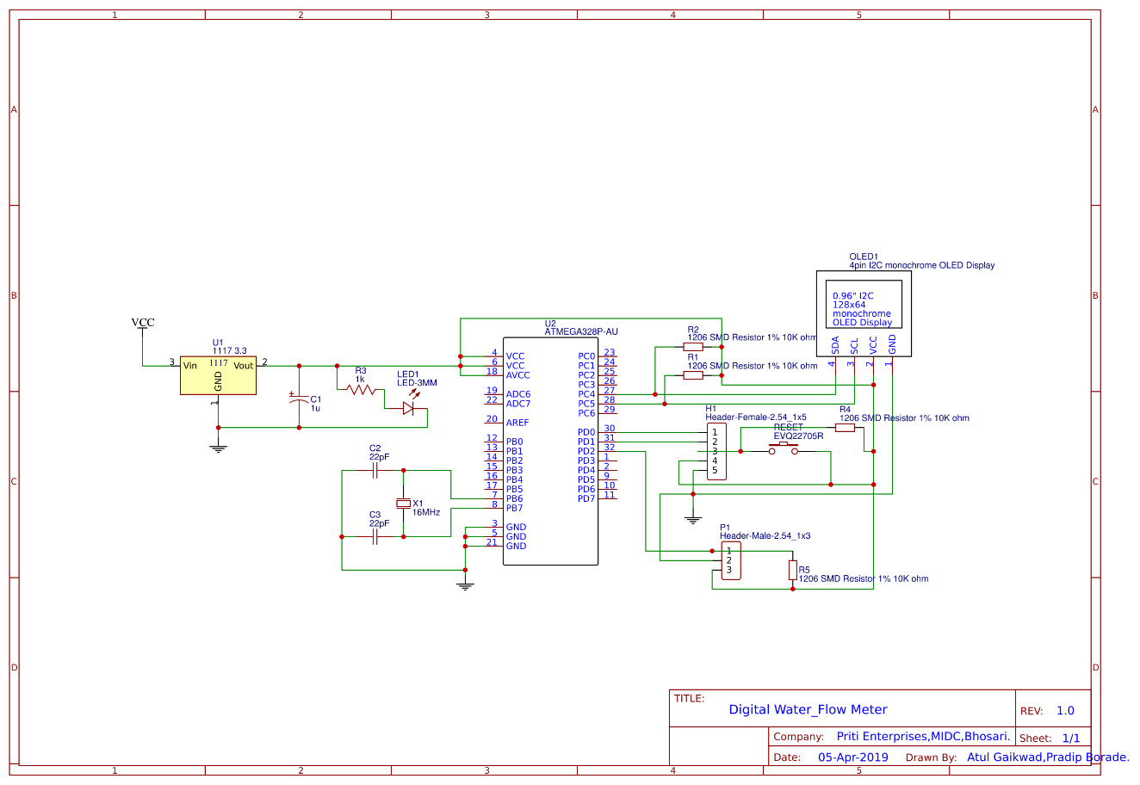

Fig. Circuit diagram

**4.2 Power supply circuit diagram**

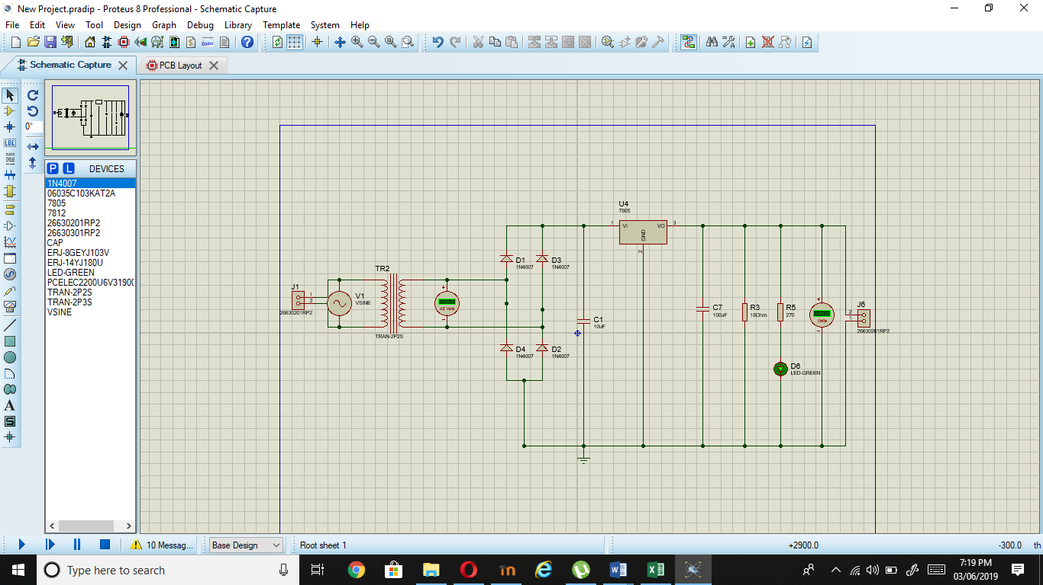

**Simulation**

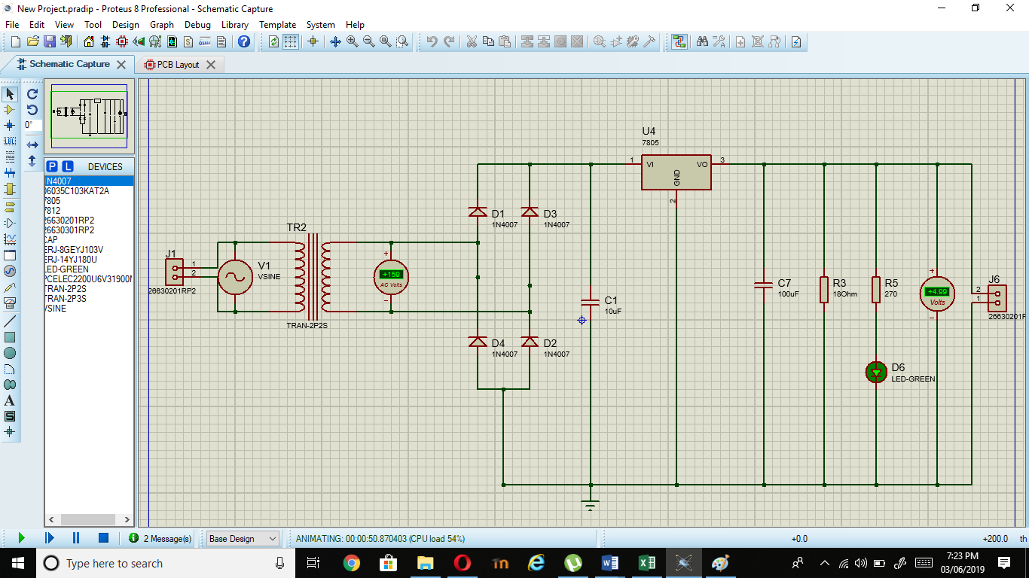

**Chapter 5**

**Programming**

**5.1 Algorithm**

1) Start.

2) Turn ON and Reset the flow meter.

3) Turn ON water pump.

4) Water passes through the flow meter.

5) Flow sensed by the Hall Effect Sensor, and gives the output as voltage.

6) This voltage is given as input to the ATmega328P.

7) Microcontroller process it and show the current flow rate and total volume passed on OLED display.

8) It shows continuously untill the flow required.

9) Stop.

**5.2 Flow chart**

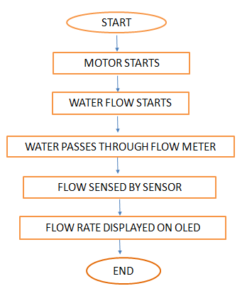

**5.3 Code**

#include <SPI.h>

#include <Wire.h>

#include <Adafruit_GFX.h>

#include <Adafruit_SSD1306.h>

#include <Fonts/FreeSerif9pt7b.h>

#define SCREEN_WIDTH 128 // OLED display width, in pixels

#define SCREEN_HEIGHT 64 // OLED display height, in pixels

// Declaration for an SSD1306 display connected to I2C (SDA, SCL pins)

#define OLED_RESET 4 // Reset pin

# (or -1 if sharing Arduino reset pin)

Adafruit_SSD1306 display(SCREEN_WIDTH, SCREEN_HEIGHT, &Wire, OLED_RESET);

/*volatile int flow_frequency; // Measures flow sensor pulses

unsigned int l_min; // Calculated litres/min

float total;

unsigned char flowsensor = 2; // Sensor Input

unsigned long currentTime;

unsigned long cloopTime;*/

int X;

int Y;

float TIME = 0;

float FREQUENCY = 0;

float WATER = 0;

float TOTAL = 0;

float LS = 0;

const int input = 2;

/*void flow () // Interrupt function

{

flow_frequency++;

}*/

void setup()

{

Serial.begin(9600);

// SSD1306_SWITCHCAPVCC = generate display voltage from 3.3V internally

if (!display.begin(SSD1306_SWITCHCAPVCC, 0x3C)) { // Address 0x3D for 128x64

Serial.println(F("SSD1306 allocation failed"));

for (;;); // Don't proceed, loop forever

}

// Clear the buffer

display.clearDisplay();

display.setFont(&FreeSerif9pt7b);

display.clearDisplay();

display.setTextSize(1);

display.setTextColor(WHITE);

display.setCursor(10, 20);

display.println("Hello, world!");

display.display();

delay(2000);

pinMode(input, INPUT);

/*digitalWrite(flowsensor, HIGH); // Optional Internal Pull-Up

attachInterrupt(0, flow, RISING); // Setup Interrupt

sei(); // Enable interrupts

currentTime = millis();

cloopTime = currentTime;*/

}

void loop ()

{

X = pulseIn(input, HIGH);

Y = pulseIn(input, LOW);

TIME = X + Y;

FREQUENCY = 1000000 / TIME;

WATER = FREQUENCY / 7.5;

LS = WATER / 60;

if (FREQUENCY >= 0)

{

if (isinf(FREQUENCY))

{

display.clearDisplay();

display.setCursor(0, 20);

display.print("VOL. :0.00");

display.print(" L/M");

display.setCursor(0, 45);

display.print("TOTAL:");

display.print( TOTAL);

display.print(" L");

display.display();

}

else

{

TOTAL = TOTAL + LS;

Serial.println(FREQUENCY);

display.clearDisplay();

display.setCursor(0, 20);

display.print("VOL.: ");

display.print(WATER);

display.print(" L/M");

display.setCursor(0, 45);

display.print("TOTAL:");

display.print( TOTAL);

display.print(" L");

display.display();

}

}

delay(1000);

/*currentTime = millis();

// Every second, calculate and print litres/hour

if (currentTime >= (cloopTime + 1000))

{

cloopTime = currentTime; // Updates cloopTime

// Pulse frequency (Hz) = 7.5Q, Q is flow rate in L/min.

l_min = (flow_frequency / 7.5); // (Pulse frequency x 60 min) / 7.5Q = flowrate in L/hour

flow_frequency = 0; // Reset Counter

Serial.print(l_min, DEC); // Print litres/hour

Serial.print(" L/M \t");

total = total + l_min / 60;

Serial.print(float(l_min / 60)); // Print litres/hour

Serial.println(" L");

display.clearDisplay();

display.setCursor(0, 15);

display.print("Current :-");

display.print(l_min);

display.println(" L/M");

display.display();

}*/

}

**Chapter 6**

**PCB Layout**

**6.1 PCB artwork**

A number of methods are available for making PCBs. The simplest is drawing a pattern on an epoxy glass board with etch and resistant ink or paint, etching the board and drilling the holes. This method is suitable where no precision is required. Another method is to make silkscreen stencil by the photographic method. Print the pattern on the epoxy glass boards, etches, and drills the holes.

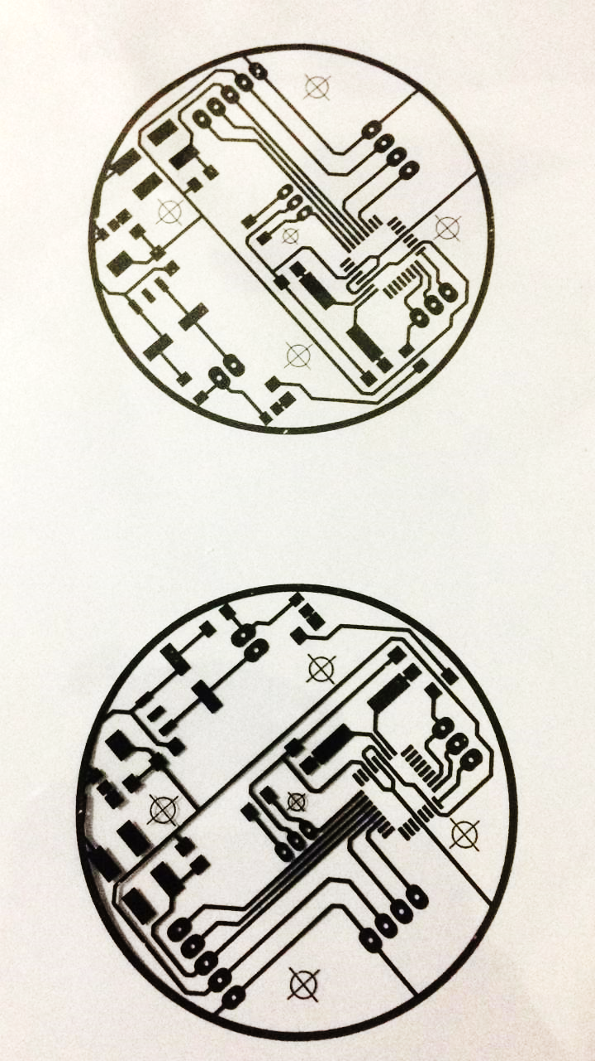

Fig. PCB layout

**6.1.1 Material**

Conducting layers are typically made of thin copper foil. Insulating layers’ dielectric are typically laminated together with epoxy resin pre prig. The board is typically coated with a solder mask that is green in color. Other colors that are normally available are blue and red. There are quite a few different dielectrics that can be chosen to provide different insulating values depending on the requirements of the circuit. Some of these dielectrics are polytetrafluoroethylene (Teflon), FR-4, FR-1, CEM-1 or CEM-3. Well known prepare materials used in the PCB industry are FR-2 (Phenol cotton paper), FR-3 (Cotton paper and epoxy), FR-4 (Woven glass and epoxy), FR-5 (Woven glass and epoxy), FR-6 (Matte glass and polyester), G-10(Woven glass and epoxy), CEM-1 (Cotton paper and epoxy), CEM-2 (Cotton paper and epoxy), CEM-3 (Woven glass and  epoxy),CEM-4 (Woven glass and epoxy), CEM-5 (Woven glass and polyester). Thermal expansion is an important consideration especially with BGA and naked die technologies, and glass fiber offers the best dimensional stability.

**6.1.2 Patterning**

The vast majority of printed circuit boards are made by bonding a layer of copper over the entire substrate, sometimes on both sides, (creating a "blank PCB") then removing unwanted copper after applying a temporary mask (e.g. by etching), leaving only the desired copper traces. A few PCBs are made by adding traces to the bare substrate (or a substrate with a very thin layer of copper) usually by a complex process of multiple electroplating steps. The PCB manufacturing method primarily depends on whether it is for production volume or sample/prototype quantities. PCB milling uses a two or three- axis mechanical milling system to mill away the copper foil from the substrate. A PCB milling machine (referred to as a 'PCB Prototype') operates in a similar way to a plotter, receiving commands from the host software that control the position of the milling head in the x, y, and (if relevant) z axis. Data to drive the Prototype is extracted from files generated in PCB design software and stored in HPGL or Gerber file format.

**6.1.3 Etching**

Chemical etching is done with ferric chloride, ammonium persulfate, or sometimes hydrochloric acid. For PTH (plated-through holes), additional steps of electro less deposition are done after the holes are drilled, then copper is electroplated to build up the thickness, the boards are screened, and plated with tin/lead. The tin/lead becomes the resist leaving the bare copper to be etched away.

**6.1.4 Drilling**

Holes through a PCB are typically drilled with tiny drill bits made of solid tungsten carbide. The drilling is performed by automated drilling machines with placement controlled by a drill tape or drill file. These computer-generated files are also called numerically controlled drill (NCD) files or "Exelon files". The drill file describes the location and size of each drilled hole. These holes are often filled with annular rings (hollow rivets) to create vials. Vials allow the electrical and thermal connection of conductors on opposite sides of the PCB. Most common laminate is epoxy filled fiberglass. Drill bit wear is partly due to embedded glass, which is harder than steel. High drill speed necessary for cost effective drilling of hundreds of holes per board causes very high temperatures at the drill bit tip, and high temperatures (400-700 degrees) soften steel and decompose (oxidize) laminate filler. Copper is softer than epoxy and interior conductors may suffer.

**6.2 Component Mounting**

**6.2.1 Soldering**

PCB soldering requires proper soldering techniques. For this one should have to use light duty soldering iron of the range 10 to 25 W. This prevents the damage of PCB due to excessive heating.

**6.2.2 Precaution**

While soldering the leads of components do not hold the soldering tip at the pins more than 10 sec. At a time, the pin should be allowed to cool to room temperature before applying hot soldering again to the same pin.

**Chapter 7**

**Result and Performance Analysis**

**Chapter 8**

**Advantages and Limitation**

**Advantages:**

* It is more reliable compare to traditional mechanical flow meters such as Rota meter.
* It is easier to read due to availability of numerical display.
* It is more accurate.

**Applications**

1. Industrial
2. Domestic
3. Irrigation system
4. **chemical industry**
5. **Food & pharma**

**Chapter 9**

**Conclusion and Recommendation**

**Conclusion**

As the technologies are getting more advanced, recognization of digitalized flow meter is getting more important, the term here we mentioned is more accuracy for fluid flowing through the flow meter. The recognization test also showed the proposed method is effective for the digitlized flow meter.

**Recommendation**

While significant progress has been made through this semester, this project is not yet complete. We can add additional battery as inbuilt power supply. It will remove two wires coming out from the ciruitory and further if we add wireless data transfer device fo transmission of current data for long distance it will automatically reduce the number of extra wires used but It will makes complex circuitory

**Chapter 10**

**Reference**

**Reference**

1. Kolhare, N.R.; Thorat, P.R. An approach of flow measurement in solar water heater using turbine flow meter. *Int. J. Eng. Res. Technol.* **2013**, *4*, 1–4.
2. Frenzel, F.; Grothey, H.; Habersetzer, C.; Hiatt, M.; Hogrefe, W.; Kirchner, M.; Lütkepohl, G.; Marchewka, W.; Mecke, U.; Ohm, M.; *et al. Industrial Flow Measurement Basics and Practices*; ABB Automation Products GmbH: Ladenburg, Germany, 2011.
3. Suribab, C.R. Differential evolution algorithm for optimal design of water distribution networks. *J. Hydroinform.* **2010**, *12*, 66–82.
4. Al-Omary, A.; El-Medany, W.; Al-Irhayim, S. Secure low cost AMR system based on GPRS technology. *Int. J. Comput. Theory Eng*. **2012**, *4*, 35–42.
5. Britton, T.C.; Stewart, R.A.; O’Halloran, K.R. Smart metering: Enabler for rapid and effective post meter leakage identification and water loss management. *J. Clean. Prod*. **2013**, *54*, 166–176.
6. Wang, S.; Garcia, R. Development of a Self-Rechargeable Digital Water Flowmeter. *J. Hydroinform.* **2013**, *15*, 888–896.
7. Whittle, A.; Girod, L.; Preis, A.; Allen, M.; Lim, H.; Iqbal, M.; Srirangarajan, S.; Fu, C.; Wong, K.; Goldsmith, D. Waterwise@SG: A testbed for continuous monitoring of the water distribution system in Singapore. *Water Disribution Syst. Anal.* **2011**, doi:10.1061/41203(425)122.
8. SEIKO EPSON Corp. *CMOS 16-bit Single Chip Microcontroller S1C17001 Technical Manual*; SEIKO EPSON Corp: Taipei, Taiwan, 2012.
9. Cavagnino, A.; Lazzari, M.; Profumo, F.; Tenconi, A. A comparison between the axial flux and the radial flux structures for PM synchronous motors. *IEEE Trans. Ind. Appl.* **2002**, *38*, 1517–1524.
10. Bumby, J.R.; Martin, R.; Mueller, M.A.; Spooner, E.; Brown, N.L.; Chalmers, B.J. Electromagnetic design of axial-flux permanent magnet machines. IEEE *Proc. Electr. Power Appl.* **2004**, *151*, 151–160.
11. Caricchi, F.; Crescimbini, F.; Honorati, O.; Bianco, G.L.; Santini, E. Performance of coreless winding axial-flux PM generator with power output at 400 Hz-3000 rev/min. *IEEE Trans. Ind. Appl.* **1998**, *34*, 1263–1269.
12. Gieras, J.F.; Wang, R.-J.; Kamper, M.J. *Axial Flux Permanent Magnet Brushless Machines*; Kluwer Academic Publisher: Dordrecht, The Netherlands, 2004.
13. Lombard, N.F.; Kamper, M.J. Analysis and performance of an ironless stator axial flux PM machine. *IEEE Trans. Energy Convers.* **1999**, *14*, 1051–1056.
14. Wang, S.; Gain, Z.; Garcia, R.; Chang, P.; Cheng, C. Development of a self-power peak expiratory flow meter. *Appl. Mech. Mater.* **2013**, *241–244*, 576–580.
15. Mitcheson, P.D.; Yeatman, E.M.; Rao, G.K.; Holmes, A.S.; Green, T.C. Energy Harvesting from Human and Machine Motion for Wireless Electronic Devices. *Proc. IEEE* **2008**, *96*, 1457–1486.
16. N.R Kolhare, P.R Thorat,(2013) “An Approach of Flow Measurement In Solar Water Heater Using Turbine Flow Meter,” International Journal of Engineering Research & Technology (IJERT), Vol. 2 pp. 1-4.
17. Luis Castaiier, Vicente Jimenez, Manuel Dom'nguez, Francesc Masana and Angel

Rodriguez,(1997) “Design and fabrication of a low cost water flow meter”, IEEE International Conference on Solid-State Sensors and Actuators, Vol. 5, pp. 159-162. Digital Object Identifier: 10.1109/SENSOR.1997.613607.

1. Shiqian Cai and Haluk Toral, (1993) “Flowrate Measurement in Air-Water Horizontal Pipeline by Neural Networks,” International Joint Conference on Neural Networks, pp.2013-2016.
2. Santhosh KV and BK Roy,(2012) “An Intelligent Flow Measurement Technique using Ultrasonic Flow Meter with Optimized Neural Network,” International Journal of Control and Automation, Vol.5, pp. 185- 196.
3. Young-Woo Lee, Seongbae Eun, Seung-Hyueb Oh,(2008) “Wireless Digital Water Meter with Low Power Consumption for Automatic Meter Reading,” International Conference on Convergence and Hybrid Information Technology IEEE, pp. 639-645. DOI 10.1109/ICHIT.19 /2008.172.
4. Javad Rezanejad Gatabi, Farshid Forouzbakhsh, HadiEbrahimi Darkhaneh, Zahra Rezanejad Gatabi, Majid Janipour, Iman Rezanejad Gatabi,(2010) “Auxillary Fluid Flow Meter,” European Journal of Scientific Research, Vol. 42 , pp. 84-92.
5. Zhang Wenzhao, Liu Zhizhuang, Xu Xiao, Liu Ailing, Chen Aiwu,(2010), “A Liquid DP Flow Sensor on Straight Pipe,” International Conference on Industrial Mechatronics and Automation, Vol. 1, pp. 481-485. Digital Object Identifier :10.1109/ICINDMA.2010.5538180.
6. Thwe Mu Han, Ohn Mar Myaing, “Design and Construction of Microcontroller-Based Water Flow Control System, ” International Conference on Circuits, System and Simulation, Vol. 7, pp. 304-309.
7. Gang-Li Qiao-Zhen Feng Dong,(2006) “Study on wide range turbine flow meter”, Proceedings of the Fifth International Conference on Machine Learning and Cybernetics IEEE, pp. 775- 778.
8. Enggcyclopedia, “Turbine Flow meters” Available: <http://www.enggcyclopedia.com/2012/01/turbineflow-meters/>
9. AKM semiconductors,“Hall Effect sensor application guide” pp 1-1. Available:

<http://www.akm.com/Brochures/HallSensortechnicalguide.pdf>.

1. N.R Kolhare, P.R Thorat,(2013) “An Approach of Flow Measurement In Solar Water Heater Using Turbine Flow Meter,” International Journal of Engineering Research & Technology (IJERT), Vol. 2,pp. 1-4.